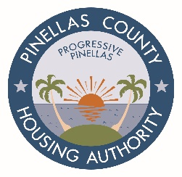

REGULAR MEETING OF THE BOARD OF COMMISSIONERS
10:00 A.M., WEDNESDAY, NOVEMBER 5, 2020

Agenda

- Call to Order

- Roll Call

- Pledge of Allegiance

- Invocation

- Minutes to be Approved – September 23, 2020 Public Hearing
September 23, 2020 Regular Meeting
October 13, 2020 Special Meeting

- Legal Reports

- Public Forum

- Resolutions

CONSENT AGENDA - The following items will be acted upon by the Board of Commissioners through a single vote. An item will be considered separately upon the request of a Commissioner:

- Resolution No. PH-20-1147 – Approval to Write-Off September 30, 2020 TARS
- Resolution No. PH-20-1148 – Approval of Central Office HVAC Upgrades

- Chair’s Report – Updated Educational Opportunities

- Executive Director Report
  - Financial Report – August 2020
  - Development Update
  - Strategic Plan Activities Update
  - Property Operations Report
  - Department/Program and Occupancy Reports

- Old Business
  - Board of Commissioners and General Counsel
  - Executive Director

- New Business
  - Board of Commissioners and General Counsel
  - Executive Director

- Next Board Meeting – To be determined

- Adjournment

