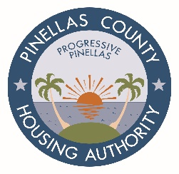

REGULAR MEETING OF THE BOARD OF COMMISSIONERS
10:00 A.M., WEDNESDAY, APRIL 28, 2021

Agenda

- Call to Order

- Roll Call

- Pledge of Allegiance

- Invocation

- Minutes to be Approved – March 24, 2021 Regular Meeting
Present: Commissioner Rouson, Commissioner Guju, Commissioner Swartz, and Commissioner Triolo

- Legal Reports

- Public Forum

- Resolutions

CONSENT AGENDA - The following items will be acted upon by the Board of Commissioners through a single vote. An item will be considered separately upon the request of a Commissioner:

  - Resolution No. PH-21-1157 – Approval of Equipment Write-Off
  - Resolution No. PH-21-1158 – Approval to Write-Off March 31, 2021 TARS
  - Resolution No. PH-21-1159 – Approval of Development Services Agreement and Construction Contract for Valor Preserve at Lake Seminole

- Chair’s Report – Educational Opportunities

- Executive Director Report
  - Financial Report – February 2021
  - Development Update
  - Property Operations Report
  - Department/Program and Occupancy Reports

- Old Business
  - Board of Commissioners and General Counsel
  - Executive Director
      - Magnolia Gardens Long Term P+L

- New Business
  - Board of Commissioners and General Counsel
  - Executive Director

- Next Board Meeting – May 26, 2021, 10:00 am

- Adjournment

